**Final Year B. Tech., Sem VII 2022-23**

**Cryptography And Network Security**

**PRN/ Roll No: 2020BTECS00206**

**Full Name: SAYALI YOGESH DESAI**

**Batch: B4**

**Assignment No. 13**

1. **Aim:**

Implementation of SHA512

1. **Theory:**

The SHA-2 family of cryptographic hash functions consists of six hash functions. These are:

1. SHA-224, with 224 bit hash values
2. SHA-256, with 256 bit hash values
3. SHA-384, with 384 bit hash values
4. SHA-512, with 512 bit hash values
5. SHA-512/224, with 512 bit hash values
6. SHA-512/256, with 512 bit hash values

Among these, SHA-256 and SHA-512 are the most commonly accepted and used hash functions computed with 32-bit and 64-bit words, respectively. SHA-224 and SHA-384 are truncated versions of SHA-256 and SHA-512 respectively, computed with different initial values.

To calculate cryptographic hashing value in Java, **MessageDigest Class** is used, under the package **java.security**.

MessagDigest Class provides following cryptographic hash function to find hash value of a text as follows:

* + MD2 and MD5
  + SHA-1
  + SHA-224
  + SHA-256
  + SHA-384
  + SHA-512

These algorithms are initialized in static method called **getInstance()**. After selecting the algorithm the message digest value is calculated and the results is returned as byte array. BigInteger class is used, to convert the resultant byte array into its signum representation. This representation is then converted into hexadecimal format to get the expected MessageDigest.

1. **Code:**

#include<bits/stdc++.h>

#define ull unsigned long long

#define SHA_512_INPUT_REPRESENTATION_LENGTH 128

#define BLOCK_SIZE 1024

#define BUFFER_COUNT 8

#define WORD_LENGTH 64

#define ROUND_COUNT 80

using namespace std;

void file()

{

#ifndef ONLINE_JUDGE

freopen("input.txt", "r", stdin);

freopen("output.txt", "w", stdout);

#endif

}

void initialiseBuffersAndConstants(vector<ull>& buffers, vector<ull>& constants)

{

buffers = {

0x6a09e667f3bcc908, 0xbb67ae8584caa73b, 0x3c6ef372fe94f82b,

0xa54ff53a5f1d36f1,

0x510e527fade682d1, 0x9b05688c2b3e6c1f, 0x1f83d9abfb41bd6b,

0x5be0cd19137e2179

};

constants = {

0x428a2f98d728ae22, 0x7137449123ef65cd, 0xb5c0fbcfec4d3b2f,

0xe9b5dba58189dbbc, 0x3956c25bf348b538,

0x59f111f1b605d019, 0x923f82a4af194f9b, 0xab1c5ed5da6d8118,

0xd807aa98a3030242, 0x12835b0145706fbe,

0x243185be4ee4b28c, 0x550c7dc3d5ffb4e2, 0x72be5d74f27b896f,

0x80deb1fe3b1696b1, 0x9bdc06a725c71235,

0xc19bf174cf692694, 0xe49b69c19ef14ad2, 0xefbe4786384f25e3,

0x0fc19dc68b8cd5b5, 0x240ca1cc77ac9c65,

0x2de92c6f592b0275, 0x4a7484aa6ea6e483, 0x5cb0a9dcbd41fbd4,

0x76f988da831153b5, 0x983e5152ee66dfab,

0xa831c66d2db43210, 0xb00327c898fb213f, 0xbf597fc7beef0ee4,

0xc6e00bf33da88fc2, 0xd5a79147930aa725,

0x06ca6351e003826f, 0x142929670a0e6e70, 0x27b70a8546d22ffc,

0x2e1b21385c26c926, 0x4d2c6dfc5ac42aed,

0x53380d139d95b3df, 0x650a73548baf63de, 0x766a0abb3c77b2a8,

0x81c2c92e47edaee6, 0x92722c851482353b,

0xa2bfe8a14cf10364, 0xa81a664bbc423001, 0xc24b8b70d0f89791,

0xc76c51a30654be30, 0xd192e819d6ef5218,

0xd69906245565a910, 0xf40e35855771202a, 0x106aa07032bbd1b8,

0x19a4c116b8d2d0c8, 0x1e376c085141ab53,

0x2748774cdf8eeb99, 0x34b0bcb5e19b48a8, 0x391c0cb3c5c95a63,

0x4ed8aa4ae3418acb, 0x5b9cca4f7763e373,

0x682e6ff3d6b2b8a3, 0x748f82ee5defb2fc, 0x78a5636f43172f60,

0x84c87814a1f0ab72, 0x8cc702081a6439ec,

0x90befffa23631e28, 0xa4506cebde82bde9, 0xbef9a3f7b2c67915,

0xc67178f2e372532b, 0xca273eceea26619c,

0xd186b8c721c0c207, 0xeada7dd6cde0eb1e, 0xf57d4f7fee6ed178,

0x06f067aa72176fba, 0x0a637dc5a2c898a6,

0x113f9804bef90dae, 0x1b710b35131c471b, 0x28db77f523047d84,

0x32caab7b40c72493, 0x3c9ebe0a15c9bebc,

0x431d67c49c100d4c, 0x4cc5d4becb3e42b6, 0x597f299cfc657e2a,

0x5fcb6fab3ad6faec, 0x6c44198c4a475817

};

}

string sha512Padding(string input)

{

string finalPlainText = "";

for (int i = 0 ; i < input.size() ; ++i)

{

finalPlainText += bitset<8>((int)input[i]).to_string();

}

finalPlainText += '1';

int plainTextSize = input.size() * 8;

int numberOfZeros = BLOCK_SIZE - ((plainTextSize +

SHA_512_INPUT_REPRESENTATION_LENGTH + 1) % BLOCK_SIZE);

while (numberOfZeros--)

{

finalPlainText += '0';

}

finalPlainText +=

bitset<SHA_512_INPUT_REPRESENTATION_LENGTH>(plainTextSize).to_string();

cout << "Plain text length = " << plainTextSize << endl;

cout << "Plain text length after padding = " << finalPlainText.length() << endl <<

endl;

return finalPlainText;

}

ull getUllFromString(string str)

{

bitset<WORD_LENGTH> word(str);

return word.to_ullong();

}

static inline ull rotr64(ull n, ull c)

{

const unsigned int mask = (CHAR_BIT * sizeof(n) - 1);

c &= mask;

return (n >> c) | (n << ((-c)&mask ));

}

int main()

{

file();

vector<ull> buffers(BUFFER_COUNT);

vector<ull> constants(ROUND_COUNT);

initialiseBuffersAndConstants(buffers, constants);

cout << "Enter Text: ";

string input;

getline(cin, input);

cout << "Input: " << input << endl;

string paddedInput = sha512Padding(input);

cout << "Padded Input:" << " " << paddedInput << endl << endl;

for (int i = 0 ; i < paddedInput.size() ; i += BLOCK_SIZE)

{

string currentBlock = paddedInput.substr(i, BLOCK_SIZE);

vector<ull> w(ROUND_COUNT);

for (int j = 0 ; j < 16 ; ++j)

{

w[j] = getUllFromString(currentBlock.substr(j, WORD_LENGTH));

}

for (int j = 16 ; j < 80 ; ++j)

{

ull sigma1 = (rotr64(w[j - 15], 1)) ^ (rotr64(w[j - 15], 8)) ^ (w[j - 15]

>> 7);

ull sigma2 = (rotr64(w[j - 2], 19)) ^ (rotr64(w[j - 2], 61)) ^ (w[j - 2] >>

6);

w[j] = w[j - 16] + sigma1 + w[j - 7] + sigma2;

}

ull a = buffers[0], b = buffers[1], c = buffers[2], d = buffers[3];

ull e = buffers[4], f = buffers[5], g = buffers[6], h = buffers[7];

for (int j = 0 ; j < ROUND_COUNT ; ++j)

{

ull sum0 = (rotr64(a, 28)) ^ (rotr64(a, 34)) ^ (rotr64(a, 39));

ull sum1 = (rotr64(e, 14)) ^ (rotr64(e, 18)) ^ (rotr64(e, 41));

ull ch = (e && f) ^ ((!e) && g);

ull temp1 = h + sum1 + ch + constants[i] + w[i];

ull majorityFunction = (a && b) ^ (a && c) ^ (b && c);

ull temp2 = sum0 + majorityFunction;

h = g;

g = f;

f = e;

e = d + temp1;

d = c;

c = b;

b = a;

a = temp1 + temp2;

}

buffers[0] += a;

buffers[1] += b;

buffers[2] += c;

buffers[3] += d;

buffers[4] += e;

buffers[5] += f;

buffers[6] += g;

buffers[7] += h;

}

cout << "Output of SHA-512 Algorithm: " << endl;

for (int i = 0 ; i < BUFFER_COUNT ; ++i)

{

cout << setfill('0') << setw(16) << right << hex << buffers[i];

}

return 0;

}

1. **Output:**

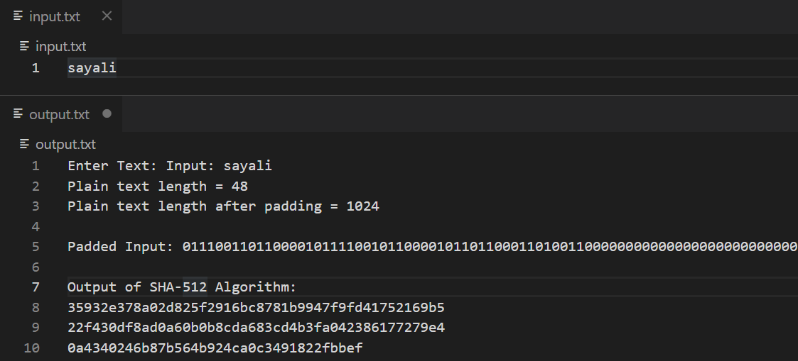

1. **Conclusion:**

Successfully implemented SHA512 Hashing Algorithm,